**CHESS TABLE CURRENT SCORE CALCULATOR**

**I.** **EXECUTE PROGRAM** **……………………………………...…2**

**II.** **ADD PATH** **……………….…2**

**III.** **SHOW RESULT** **…….………………….3**

# **EXECUTE PROGRAM**

Run the code. Just, King(Şah),Queen(Vezir),Pawn(Piyon),Horse(At) cases detected with that program.

You will see console application like in the below:

# 

# **ADD PATH**

Example txt format :

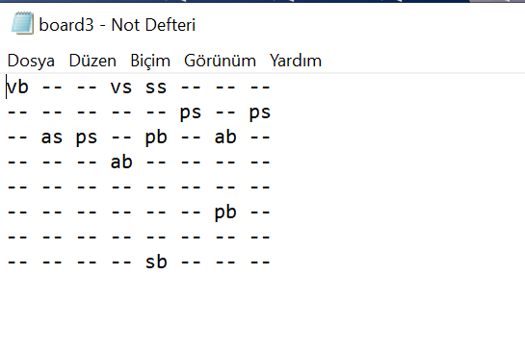

For customizing you can add your new path.

# **SHOW RESULT**

Program immediately show the result when you add correct format and correct path.

